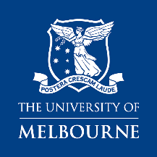 | Melbourne Medical School  Indigenous Development Grant 2022  Authority to Submit form
This document is required to be completed and submitted as part of team-based applications to the MMS Indigenous Development Grant scheme. For more information please refer to the Instructions to Applicants or contact Patricia Gigliuto: plgi@unimelb.edu.au
Electronic signatures are accepted.
Certification by Lead applicant
I certify that:
- To the best of my knowledge, all information included in this application is true and correct. Information about others has been provided with their consent.
- To the best of my knowledge, all named participants on the proposal meet the eligibility criteria of the scheme
- I consent to be the primary administrative contact regarding this application.
- If this proposal is funded, I will be responsible for oversight of the supported activity, appropriate use of grant funds and the submission of progress reports.
- I will notify the Melbourne Medical School of any material changes affecting application information as soon as practicable.
Applicant Name | MMS Department | Signature | Date

Certification by other participants
I certify that:
- To the best of my knowledge, all information included in this application is true and correct and has been provided with my consent
- I consent the lead applicant named above to submit this application on my behalf

Applicant Name | MMS Department | Signature | Date

