Department of Psychiatry
Melbourne Neuropsychiatry Centre

Opportunities at Melbourne Neuropsychiatry Centre

Available Masters and PhD Projects - starting in 2015
Contents
Opportunities at Melbourne Neuropsychiatry Centre 1
Available Masters and PhD Projects 1
Puberty, brain development and mental health during the transition from childhood to adolescence. 2
Mapping the Human Schizophrenia Connectome. 3
Human Connectome Bioinformatics. 4
Modelling and Simulation of Interconnected Neuronal Populations. 5
Brain Network Dynamics in Health and Disease. 6
Towards a brain-based measure of human anxiety sensitivity 7
Predicting treatment response in young people with major depression using functional neuroimaging 8

Puberty, brain development and mental health during the transition from childhood to adolescence.

We are seeking an enthusiastic and motivated candidate for a PhD project beginning in the first half of 2015. The project is a joint initiative of the Melbourne Neuropsychiatry Centre (Department of Psychiatry) and the Melbourne School of Psychological Sciences, The University of Melbourne, and the Murdoch Childrens Research Institute, Victoria, Australia. The candidate, supervised by Dr. Sarah Whittle, will be required to contribute to a unique longitudinal study that aims to investigate the association between puberty, brain development, and mental health, from late childhood to mid-adolescence. The successful candidate will have the opportunity to craft a thesis topic that suits their interests, and may utilise a range of data being collected, including structural and functional imaging, hormonal, environmental (e.g., parenting), and mental health data.

We welcome enquiries from students with their own funding. However, for the right applicant, the position may be funded at the equivalent rate of an Australian Postgraduate Award.

The successful applicant should have an undergraduate and/or honours degree in a relevant field, have good results (first or upper second class honours or equivalent) and/or have relevant research experience. Experience in clinical interviewing, endocrinology, or structural or functional MRI analysis will be looked upon favourably.

Supervisors: Dr. Sarah Whittle
Location: Melbourne Neuropsychiatry Centre, Department of Psychiatry, The University of Melbourne
Contact: swhittle@unimelb.edu.au

Mapping the Human Schizophrenia Connectome.

This project aims to comprehensively map the entire human connectome in schizophrenia. The student will complete one of the largest clinical connectome mapping studies undertaken in the world by analysing high-quality brain imaging data in more than 330 individuals with schizophrenia provided by the Australian Schizophrenia Research Bank (ASRB). The ASRB is the largest brain research project ever undertaken in Australia. This project will apply advanced fibre tracking algorithms to the diffusion-MRI brain imaging data acquired in each patient, with the goal of comprehensively mapping all disrupted connections comprising the entire schizophrenia connectome. VLSCI computational resources may be utilised for this purpose.

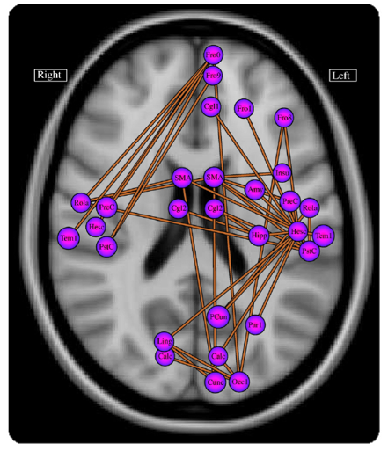
Figure: Disruptions to functional brain connectivity in schizophrenia.
Primary Contact: Andrew Zalesky, azalesky@unimelb.edu.au
Collaborators: Alex Fornito (Monash Biomedical Imaging), Luca Cocchi (Queensland Brain Institute), Christos Pantelis (Melbourne Neuropsychiatry Centre)
Keywords: Schizophrenia, biological psychiatry, connectome, tractography.
Suggested Reading:
- [1] Disrupted axonal fiber connectivity in schizophrenia (2011) Zalesky A, Fornito A, Seal ML, Cocchi L, Westin C-F, Bullmore ET, Egan GF, Pantelis C. Biol Psychiatry. 69(1):80-89.
- [2] Schizophrenia, neuroimaging and connectomics (2012) Fornito A, Zalesky A, Pantelis C, Bullmore E. NeuroImage. 62(4):2296-2314.
- [3] The relationship between regional and inter-regional functional connectivity deficits in schizophrenia (2012) Zalesky A, Fornito A, Egan GF, Pantelis C, Bullmore E. Hum Brain Mapp. 33(11):2535-2549.
Location: Melbourne Neuropsychiatry Centre, Department of Psychiatry, National Neuroscience Facility, Level 2-3 Alan Gilbert Building.

Human Connectome Bioinformatics.

The connectome refers to a comprehensive network description of the brain’s internal wiring. Advances in magnetic resonance imaging (MRI) have enabled reliable mapping of the large-scale connectome in the living human brain. Comparing the human connectome between healthy and diseased brains has identified disease-specific anomalies in brain circuitry that may provide novel therapeutic targets and potential biomarkers to assess risk and predict patient outcomes. This project aims to develop advanced bioinformatic tools that capitalise on these advances. The student will develop methods to perform statistically valid network-level inference on the connectome. Overcoming limitations of the widely used network-based statistic (NBS) will be the project’s starting point. This project will deliver powerful bioinformatic tools to enable neuroscientists and psychiatrists to accurately and reliably map connectome pathology in the diseased brain. The field of connectome bioinformatics is expected to grow rapidly in response to the abundance of connectomic data that will be made publicly available as part of the $40 million Human Connectome Project. This project is suited to a student with a background in statistics and algorithm development.

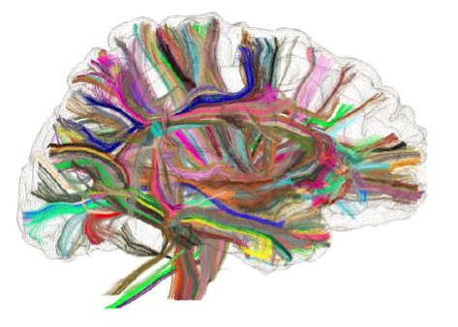
Figure: The human connectome mapped using diffusion-MRI and tractography.

Primary Contact: Andrew Zalesky, azalesky@unimelb.edu.au
Collaborators: David Grayden (University of Melbourne), Tony Burkitt (University of Melbourne), Rao Kotagiri (University of Melbourne), Leonardo Gollo (Queensland Institute of Medical Research), Michael Breakspear (Queensland Institute of Medical Research), Fernando Calamante (Florey Institute of Neuroscience and Mental Health)
Keywords: Connectome bioinformatics, biostatistics, network-based statistic (NBS), network inference.
Suggested Reading:
[1] Network-based statistic: Identifying differences in brain networks (2010) Zalesky A, Fornito A, Bullmore ET. NeuroImage. 53(4):1197-1207.
[2] Connectivity differences in brain networks (2012) Zalesky A, Cocchi L, Fornito A, Murray MM, Bullmore E. NeuroImage. 60(2):1055-1062.
[3] Learning and comparing functional connectomes across subjects (2013) Varoquaux G, Craddock RC. NeuroImage. 80:405-415.
Location: Melbourne Neuropsychiatry Centre, Department of Psychiatry, National Neuroscience Facility, Level 2-3 Alan Gilbert Building.

Modelling and Simulation of Interconnected Neuronal Populations.

The spatiotemporal coordination of neural activity is constrained by the brain’s anatomy, namely, the network of axonal fibre pathways that enable communication between distant brain regions. This project aims to simulate hundreds of distinct neuronal populations that are interconnected via a biologically realistic network of axonal fibre pathways. The neuroanatomical network will be mapped using diffusion-MRI data acquired in living humans to yield a large-scale “wiring diagram” for the whole brain, telling us which neuronal populations are to be interconnected with each other in the network model. Neuronal population dynamics will be modelled and simulated using the Morris-Lecar neural mass model. The student will use the model to systematically disrupt groups of connections, as is consistent with brain disease, and investigate the consequence of these connectivity disruptions on the spatiotemporal coordination of neural activity and the brain’s functional modules. The student will then optimise and rewire the brain’s actual neuroanatomical network to improve its resilience and robustness to attack. This project will involve numerical solution of large systems of delay differential equations and is suited to a student with a background in numerical computation. VLSCI computational resources may be utilised for this purpose.

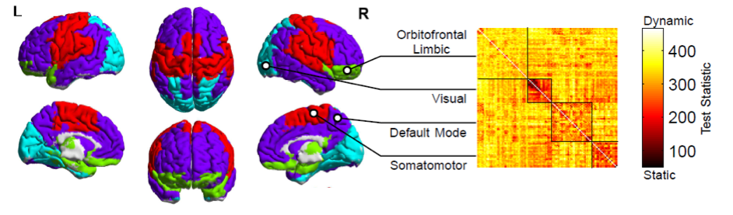
Figure: Decomposition of the brain into four distinct modules based on functional connectivity. Inter-modular connections are predominantly dynamic, whereas intra-modular connections are static.

Primary Contact: Andrew Zalesky, azalesky@unimelb.edu.au
Collaborators: David Grayden (University of Melbourne), Tony Burkitt (University of Melbourne), Rao Kotagiri (University of Melbourne), Leonardo Gollo (Queensland Institute of Medical Research), Michael Breakspear (Queensland Institute of Medical Research), Fernando Calamante (Florey Institute of Neuroscience and Mental Health)
Keywords: Neural mass model, brain connectivity, diffusion-MRI, network robustness.
Suggested Reading:
[1] Modulation of excitatory synaptic coupling facilitates synchronization and complex dynamics in a biophysical model of neuronal dynamics (2003) Breakspear M, Terry JR, Friston KJ. Network. 14(4):703-732.
[2] Network structure of cerebral cortex shapes functional connectivity on multiple time scales (2007) Honey CJ, Kotter R, Breakspear M, Sporns O. Proc Natl Acad Sci U S A. 104(24):10240-10245.
[3] Modeling the impact of lesions in the human brain (2009) Alstott J, Breakspear M, Hagmann P, Cammoun L, Sporns O. PLoS Comput Biol. 5(6):e1000408.
Location: Melbourne Neuropsychiatry Centre, Department of Psychiatry, National Neuroscience Facility, Level 2-3 Alan Gilbert Building.

Brain Network Dynamics in Health and Disease.

Brain activity displays a complex spatiotemporal structure, involving dynamically fluctuating patterns of coordination in neural activity among a large number of brain regions and over a diverse range of timescales. This project aims to investigate the large-scale network dynamics of the human brain in health and disease. Brain imaging data acquired in living humans will be used to develop dynamic network models of neural activity that encompass the whole brain. Network nodes will correspond to cortical and subcortical brain regions and the connectivity between pairs of nodes will be inferred from high-quality resting-state functional-MRI data that has already been acquired in a large group of patients diagnosed with schizophrenia and a matched group of healthy individuals. The student will apply cutting-edge network science techniques to study the dynamic behaviour of the brain’s network hubs, modules and its so-called “rich club”. This project will deliver network-based brain biomarkers that can accurately and reliably differentiate healthy and diseased brains using brain imaging data. Depending on the student’s interest, opportunities will be made available to investigate psychiatric disorders other than schizophrenia.

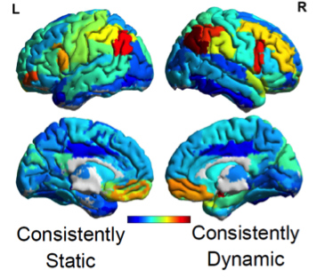
Figure: Brain regions most consistently forming dynamic functional connections in the resting state.

Primary Contact: Andrew Zalesky, azalesky@unimelb.edu.au
Collaborators: Luca Cocchi (Queensland Brain Institute), Alex Fornito (Monash Biomedical Imaging), Michael Breakspear (Queensland Institute of Medical Research), Christos Pantelis (Melbourne Neuropsychiatry Centre), Rao Kotagiri (University of Melbourne)
Keywords: Network science, brain connectivity, functional neuroimaging, biological psychiatry.
Suggested Reading:
- [1] Graph analysis of the human connectome: Promise, progress, and pitfalls (2013) Fornito A, Zalesky A, Breakspear M. NeuroImage. 80:426-444.
- [2] Disrupted axonal fiber connectivity in schizophrenia (2011) Zalesky A, Fornito A, Seal ML, Cocchi L, Westin C-F, Bullmore ET, Egan GF, Pantelis C. Biol Psychiatry. 69(1):80-89.
- [3] Network-based statistic: Identifying differences in brain networks (2010) Zalesky A, Fornito A, Bullmore ET. NeuroImage. 53(4):1197-1207
Location: Melbourne Neuropsychiatry Centre, Department of Psychiatry, National Neuroscience Facility, Level 2-3 Alan Gilbert Building.

Towards a brain-based measure of human anxiety sensitivity

Anxiety disorders are the most prevalent and costly of all mental disorders for Australians aged between 18 and 45 years. Despite this, we lack a clear understanding of the biological mechanisms that give rise to their symptoms and how to effectively treat them.
This PhD project will test the hypothesis that human anterior insular cortex activity underlies individual differences in trait “anxiety sensitivity”: an established psychological risk factor for clinical anxiety disorders. The project will recruit a large cohort of adolescent and young adult participants and assess them with functional magnetic resonance imaging (fMRI) combined with psychophysiological monitoring. As well as characterising the brain basis of human anxiety sensitivity, it is expected that this project will identify a novel biological risk marker of clinical anxiety, in particular, panic disorder. We have close collaborations with Orygen Youth Health and headspace Western Melbourne, and there is scope for the project to be extended to patient groups from these clinics.
Candidates with an interest in psychology, biological psychiatry and imaging neuroscience are encouraged to apply. Further detail about this project is available upon request.

Supervisors: Dr. Ben Harrison, Dr. Chris Davey
Location: Melbourne Neuropsychiatry Centre, and Department of Psychiatry, The University of Melbourne

Contact: Dr. Ben Harrison T: 03 8344 1876 E: habj@unimelb.edu.au

Predicting treatment response in young people with major depression using functional neuroimaging

Mental illnesses are the "chronic diseases of the young", and the mental illness that causes most disability in young people is depression. While antidepressant medications are an effective treatment for adolescent depression, only about two-thirds of patients will demonstrate a clinical response, and less than a third will reach remission. The identification of valid biomakers to assist in the prediction of treatment response is therefore of great clinical relevance.
This PhD project will use functional magnetic resonance imaging (fMRI) combined with novel emotional provocation tasks. We will test the hypothesis that individual differences in pretreatment activity of the medial frontal cortex will predict treatment response in young patients experiencing their first episode of depression. Patients will be recruited from Orygen Youth Health and headspace Western Melbourne, where Dr Davey works as a psychiatrist.
Candidates with an interest in psychology, biological psychiatry and imaging neuroscience are encouraged to apply. Further detail about this project is available upon request.

Supervisors: Dr. Chris Davey, Dr. Ben Harrison
Location: Melbourne Neuropsychiatry Centre, and Department of Psychiatry, The University of Melbourne

Contact: Dr. Chris Davey T: 03 9342 2800 E: c.davey@unimelb.edu.au

