Department of Psychiatry
Melbourne Neuropsychiatry Centre

Opportunities at Melbourne Neuropsychiatry Centre

Available Honours Projects - starting in 2015
Contents
Opportunities at Melbourne Neuropsychiatry Centre 1
Available Honours Projects - starting in 2015 1
Mapping the Human Schizophrenia Connectome. 2
Human Connectome Bioinformatics. 3
Modelling and Simulation of Interconnected Neuronal Populations. 4
Brain Network Dynamics in Health and Disease. 5
Characterisation of physiological stress responses in patients with depression and epilepsy. 6
MRI volumetry and shape analysis in frontotemporal dementia and schizophrenia 7
The relationship between cognitive function, physical disability and quality of life in patients with multiple sclerosis. 8
Investigating structural co-variance between brain regions in schizophrenia 9

Mapping the Human Schizophrenia Connectome.

This project aims to comprehensively map the entire human connectome in schizophrenia. The student will complete one of the largest clinical connectome mapping studies undertaken in the world by analysing high-quality brain imaging data in more than 330 individuals with schizophrenia provided by the Australian Schizophrenia Research Bank (ASRB). The ASRB is the largest brain research project ever undertaken in Australia. This project will apply advanced fibre tracking algorithms to the diffusion-MRI brain imaging data acquired in each patient, with the goal of comprehensively mapping all disrupted connections comprising the entire schizophrenia connectome. VLSCI computational resources may be utilised for this purpose.

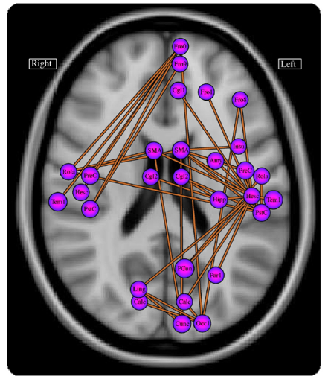
Figure: Disruptions to functional brain connectivity in schizophrenia.
Primary Contact: Andrew Zalesky, azalesky@unimelb.edu.au
Collaborators: Alex Fornito (Monash Biomedical Imaging), Luca Cocchi (Queensland Brain Institute), Christos Pantelis (Melbourne Neuropsychiatry Centre)
Keywords: Schizophrenia, biological psychiatry, connectome, tractography.
Suggested Reading:
- [1] Disrupted axonal fiber connectivity in schizophrenia (2011) Zalesky A, Fornito A, Seal ML, Cocchi L, Westin C-F, Bullmore ET, Egan GF, Pantelis C. Biol Psychiatry. 69(1):80-89.
- [2] Schizophrenia, neuroimaging and connectomics (2012) Fornito A, Zalesky A, Pantelis C, Bullmore E. NeuroImage. 62(4):2296-2314.
- [3] The relationship between regional and inter-regional functional connectivity deficits in schizophrenia (2012) Zalesky A, Fornito A, Egan GF, Pantelis C, Bullmore E. Hum Brain Mapp. 33(11):2535-2549.
Location: Melbourne Neuropsychiatry Centre, Department of Psychiatry, National Neuroscience Facility, Level 2-3 Alan Gilbert Building.

Human Connectome Bioinformatics.

The connectome refers to a comprehensive network description of the brain’s internal wiring. Advances in magnetic resonance imaging (MRI) have enabled reliable mapping of the large-scale connectome in the living human brain. Comparing the human connectome between healthy and diseased brains has identified disease-specific anomalies in brain circuitry that may provide novel therapeutic targets and potential biomarkers to assess risk and predict patient outcomes. This project aims to develop advanced bioinformatic tools that capitalise on these advances. The student will develop methods to perform statistically valid network-level inference on the connectome. Overcoming limitations of the widely used network-based statistic (NBS) will be the project’s starting point. This project will deliver powerful bioinformatic tools to enable neuroscientists and psychiatrists to accurately and reliably map connectome pathology in the diseased brain. The field of connectome bioinformatics is expected to grow rapidly in response to the abundance of connectomic data that will be made publicly available as part of the $40 million Human Connectome Project. This project is suited to a student with a background in statistics and algorithm development.

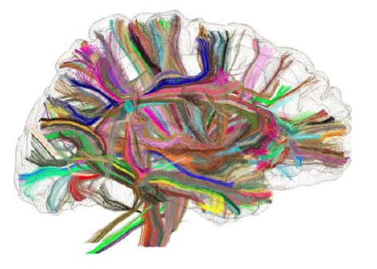
Figure: The human connectome mapped using diffusion-MRI and tractography.

Primary Contact: Andrew Zalesky, azalesky@unimelb.edu.au
Collaborators: David Grayden (University of Melbourne), Tony Burkitt (University of Melbourne), Rao Kotagiri (University of Melbourne), Leonardo Gollo (Queensland Institute of Medical Research), Michael Breakspear (Queensland Institute of Medical Research), Fernando Calamante (Florey Institute of Neuroscience and Mental Health)
Keywords: Connectome bioinformatics, biostatistics, network-based statistic (NBS), network inference.
Suggested Reading:
[1] Network-based statistic: Identifying differences in brain networks (2010) Zalesky A, Fornito A, Bullmore ET. NeuroImage. 53(4):1197-1207.
[2] Connectivity differences in brain networks (2012) Zalesky A, Cocchi L, Fornito A, Murray MM, Bullmore E. NeuroImage. 60(2):1055-1062.
[3] Learning and comparing functional connectomes across subjects (2013) Varoquaux G, Craddock RC. NeuroImage. 80:405-415.
Location: Melbourne Neuropsychiatry Centre, Department of Psychiatry, National Neuroscience Facility, Level 2-3 Alan Gilbert Building.

Modelling and Simulation of Interconnected Neuronal Populations.

The spatiotemporal coordination of neural activity is constrained by the brain’s anatomy, namely, the network of axonal fibre pathways that enable communication between distant brain regions. This project aims to simulate hundreds of distinct neuronal populations that are interconnected via a biologically realistic network of axonal fibre pathways. The neuroanatomical network will be mapped using diffusion-MRI data acquired in living humans to yield a large-scale “wiring diagram” for the whole brain, telling us which neuronal populations are to be interconnected with each other in the network model. Neuronal population dynamics will be modelled and simulated using the Morris-Lecar neural mass model. The student will use the model to systematically disrupt groups of connections, as is consistent with brain disease, and investigate the consequence of these connectivity disruptions on the spatiotemporal coordination of neural activity and the brain’s functional modules. The student will then optimise and rewire the brain’s actual neuroanatomical network to improve its resilience and robustness to attack. This project will involve numerical solution of large systems of delay differential equations and is suited to a student with a background in numerical computation. VLSCI computational resources may be utilised for this purpose.

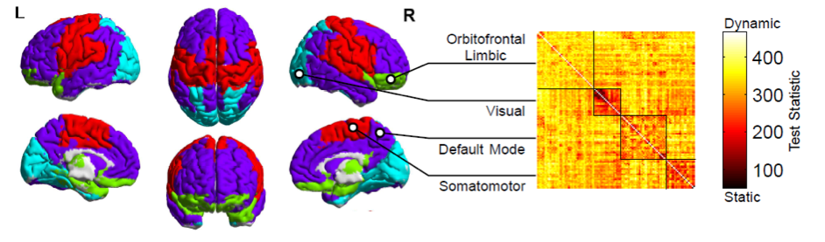
Figure: Decomposition of the brain into four distinct modules based on functional connectivity. Inter-modular connections are predominantly dynamic, whereas intra-modular connections are static.

Primary Contact: Andrew Zalesky, azalesky@unimelb.edu.au
Collaborators: David Grayden (University of Melbourne), Tony Burkitt (University of Melbourne), Rao Kotagiri (University of Melbourne), Leonardo Gollo (Queensland Institute of Medical Research), Michael Breakspear (Queensland Institute of Medical Research), Fernando Calamante (Florey Institute of Neuroscience and Mental Health)
Keywords: Neural mass model, brain connectivity, diffusion-MRI, network robustness.
Suggested Reading:
[1] Modulation of excitatory synaptic coupling facilitates synchronization and complex dynamics in a biophysical model of neuronal dynamics (2003) Breakspear M, Terry JR, Friston KJ. Network. 14(4):703-732.
[2] Network structure of cerebral cortex shapes functional connectivity on multiple time scales (2007) Honey CJ, Kotter R, Breakspear M, Sporns O. Proc Natl Acad Sci U S A. 104(24):10240-10245.
[3] Modeling the impact of lesions in the human brain (2009) Alstott J, Breakspear M, Hagmann P, Cammoun L, Sporns O. PLoS Comput Biol. 5(6):e1000408.
Location: Melbourne Neuropsychiatry Centre, Department of Psychiatry, National Neuroscience Facility, Level 2-3 Alan Gilbert Building.

Brain Network Dynamics in Health and Disease.

Brain activity displays a complex spatiotemporal structure, involving dynamically fluctuating patterns of coordination in neural activity among a large number of brain regions and over a diverse range of timescales. This project aims to investigate the large-scale network dynamics of the human brain in health and disease. Brain imaging data acquired in living humans will be used to develop dynamic network models of neural activity that encompass the whole brain. Network nodes will correspond to cortical and subcortical brain regions and the connectivity between pairs of nodes will be inferred from high-quality resting-state functional-MRI data that has already been acquired in a large group of patients diagnosed with schizophrenia and a matched group of healthy individuals. The student will apply cutting-edge network science techniques to study the dynamic behaviour of the brain’s network hubs, modules and its so-called “rich club”. This project will deliver network-based brain biomarkers that can accurately and reliably differentiate healthy and diseased brains using brain imaging data. Depending on the student’s interest, opportunities will be made available to investigate psychiatric disorders other than schizophrenia.

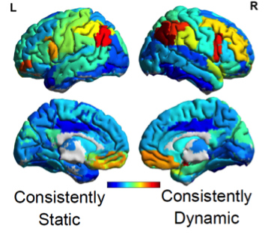
Figure: Brain regions most consistently forming dynamic functional connections in the resting state.

Primary Contact: Andrew Zalesky, azalesky@unimelb.edu.au
Collaborators: Luca Cocchi (Queensland Brain Institute), Alex Fornito (Monash Biomedical Imaging), Michael Breakspear (Queensland Institute of Medical Research), Christos Pantelis (Melbourne Neuropsychiatry Centre), Rao Kotagiri (University of Melbourne)
Keywords: Network science, brain connectivity, functional neuroimaging, biological psychiatry.
Suggested Reading:
- [1] Graph analysis of the human connectome: Promise, progress, and pitfalls (2013) Fornito A, Zalesky A, Breakspear M. NeuroImage. 80:426-444.
- [2] Disrupted axonal fiber connectivity in schizophrenia (2011) Zalesky A, Fornito A, Seal ML, Cocchi L, Westin C-F, Bullmore ET, Egan GF, Pantelis C. Biol Psychiatry. 69(1):80-89.
- [3] Network-based statistic: Identifying differences in brain networks (2010) Zalesky A, Fornito A, Bullmore ET. NeuroImage. 53(4):1197-1207
Location: Melbourne Neuropsychiatry Centre, Department of Psychiatry, National Neuroscience Facility, Level 2-3 Alan Gilbert Building.

Characterisation of physiological stress responses in patients with depression and epilepsy.
Depression and epilepsy are disabling disorders that are common in the community. Both disorders have been shown to have effects on the human body’s physiological response to stress. These effects have been identified in both the autonomic nervous system (responsible for immediate responses to stress) and the hypothalamic-pituitary-adrenal axis (which mediates longer-term stress responses). However, it is not known whether these effects occur through similar mechanisms, partly because previous research has not focused extensively on patients with both disorders. This project will broaden our understanding of stress physiology in these disorders by assessing stress physiology in patients who have been admitted to hospital for assessment of seizures and have one or both disorders.

Aims: To compare the effects of depression and epilepsy, particularly temporal lobe epilepsy, human physiological stress responses and to assess whether these effects are additive or have a more complex interaction.

Methods: The project will measure parameters of the physiological stress response in patients who have been admitted to investigate their epilepsy. Assessment of the autonomic nervous system will use a variety of measures of heart rate variability, and the HPA axis will be measured by the level of the hormone cortisol in saliva. Clinical data will be obtained by working with the clinical team caring for the patient and involves direct patient contact.

Outcome: To better understand stress physiology in depression (a psychiatric illness) and epilepsy (a neurological disorder) by assessing their interaction.

Supervisors: Dr Dennis Velakoulis, Professor Terry O’Brien and Dr Chris Turnbull

Location: Melbourne Neuropsychiatry Centre, Royal Melbourne Hospital and Alan Gilbert Building, University of Melbourne

Contact: Dr Dennis Velakoulis T: 93428750 E: dennis.velakoulis@mh.org.au

MRI volumetry and shape analysis in frontotemporal dementia and schizophrenia

Principal Investigator: Dr Dennis Velakoulis and Dr Mark Walterfang

Location: Melbourne Neuropsychiatry Centre, Royal Melbourne Hospital

Project Type: Honours, Masters or PhD

Overview:
It has been well recognised for over a century that some patients with schizophrenia develop a dementia but the nature of this dementia has remained unclear. Recent clinical, neuropathological and genetic studies have identified a previously unrecognised association between chronic schizophrenia and frontotemporal dementia. This project aims to examine whether the volume and shape changes identified in schizophrenia are quantitatively and qualitatively similar to patients with a frontotemporal dementia. In addition to demographic and diagnostic information a subset of the subjects have neuropsychological and bedside screening cognitive testing which can be correlated with brain structural volumes and shape.
Aims: To estimate and compare brain structure volume and shape in an existing database of MRI images of patients with chronic schizophrenia and frontotemporal dementia compared to control subjects.
Methods: Specific regions of interest to examine would include:

- Frontal and temporal lobes
- Orbitofrontal / dorsolateral / medial frontal cortex
- hippocampus
- Insula cortex
- Superior temporal gyrus

Depending on the region of interest the project would require the learning of methods for analysing the region and developing a reliable method for this assessment.

Outcome: To assess and compare the nature and pattern of brain changes in chronic schizophrenia and FTD.

Contact: Dr Dennis Velakoulis T: 93428750 E: dennis.velakoulis@mh.org.au

The relationship between cognitive function, physical disability and quality of life in patients with multiple sclerosis.

Multiple sclerosis (MS) is an inflammatory demyelinating disease of the CNS, characterized by relapses and remissions of neurological impairment. MS is associated with physical, cognitive, affective and functional impairments. Cognitive deficits in attention, memory and executive skills are often prominent, and have been found to correlate with functional disturbance and the degree of MRI white matter abnormalities. The ongoing MS research work at Royal Park includes a database of over 200 MS subjects who have had cognitive, physical disability and functional assessments.

Aims: To examine the relationship between cognitive, physical and functional disability in patients with MS. We would hypothesise that patients with greater cognitive deficits will exhibit a greater degree of functional impairment.

Methods: The proposed project will include the assessment of patients across cognitive, physical and functional domains to add to the existing database, followed by analysis of the relationships between these variables.

Outcome: Identifying the determinants of poor outcome in MS will assist in early intervention and prevention of poor outcomes by identifying those at greatest risk.

Supervisors: Associate Professor Fary Khan, Dr Dennis Velakoulis and Dr Mark Walterfang
Location: Royal Park Campus, Royal Melbourne Hospital

Contact: A/Prof Fary Khan E: Fary.Khan@mh.org.au

Investigating structural co-variance between brain regions in schizophrenia

A large body of research has demonstrated that there are reductions in grey matter volume in individuals with schizophrenia. These are most pronounced in select frontal and temporal regions such as the anterior cingulate, medial and inferior frontal cortices, superior temporal gyrus, hippocampus, thalamus and insula. As these regions are involved in a number of higher-order cognitive and behavioural processes, such loss of brain volume may have wide-reaching implications for everyday functioning.

Although the demonstration of volumetric differences in schizophrenia has been informative, it is increasingly recognised that single brain regions do not function in isolation but in an organised fashion. It is also known that communities of brain regions co-vary with other brain regions – a phenomenon called structural covariance. Despite schizophrenia being conceptualised as a disorder of brain connectivity, inter-regional structural covariance networks are not well characterised in individuals with this disorder.

The proposed honours project will investigate whether there are differences in the pattern of structural co-variance of brain regions in individuals with established schizophrenia compared to healthy controls and/or between subgroups of individuals with the disorder. This will be done using an imaging approach called ‘voxel-based morphology’, where grey matter volume at each voxel will be compared across the brain and between groups of subjects. The student will be responsible for the pre-processing and statistical analysis of MRI scans that have been collected from the Australian Schizophrenia Research Bank. The student will also be trained in the application of imaging analysis in neuropsychiatry.

Category for project (e.g. Neuropsychiatry, Epilepsy, Malaria): Neuropsychiatry

Supervisors names and contact details: Dr Paul Klauser (paul.klauser@unimelb.edu.au), Dr Vanessa Cropley (vcropley@unimelb.edu.au), A/Prof Alex Fornito (alex.fornito@monash.edu), Prof Christos Pantelis (cpant@unimelb.edu.au)

Location where student will be undertaking study: Melbourne Neuropsychiatry Centre, 161 Barry Street, Carlton South, The University of Melbourne.

